We are very excited to announce our 2014 OUTSpoken Guest Speakers = "The Read" featuring Kid Fury and Crissle West, Thursday, October 16, 7pm in McKnight Hall/Cone Center. Please help us to spread the word.
Known for their ability to bring flippant humor and incisive cultural critique, bloggers and queer youth media activists Kid Fury and Crissle West host a special episode of their popular podcast "The Read," live at UNC Charlotte to help commemorate National Coming Out Week!
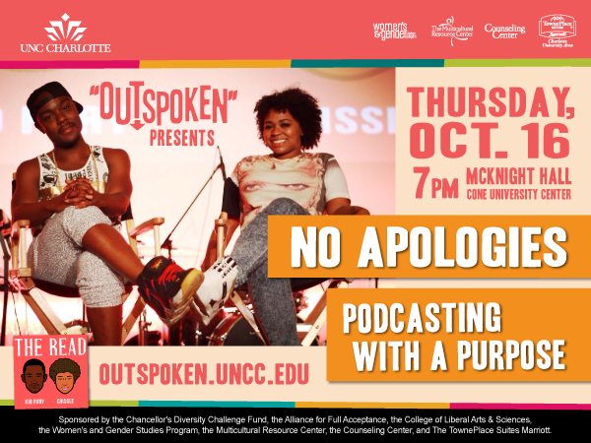
Born in Miami and now living in New York City, Kid Fury is a media mouthpiece with a whole lot of nerve. In June 2006, he created an urban news/gossip site called The Fury, which has since become a popular award-winning blog. With over hundreds of thousands of hits a day, The Fury has become a staple in daily pop culture news for the snarky. With Kid Fury TV, a YouTube channel currently holding over 94,000 subscribers, and chart-topping new podcast The Read, Kid Fury is pushing boundaries and breaking new ground.
Born in Louisiana and raised in Oklahoma, writer Crissle West moved to New York City in 2012. Her work has been published in ESSENCE magazine and she has appeared as a panelist on gender identity and sexuality at New York University. Crissle’s thoughtful essays can be found on her eponymous website.
As queer youth, Kid Fury and Crissle West were selected as presenters for the 2014 OUTSpoken Speaker Series. This annual event was created to focus on LGBTQIA issues, and it aims to positively influence the campus climate to make it a more accepting and affirming place for students, faculty, staff and the community.

