We are excited to announce our 2014 WGST Guest Speaker, Dr. Michael Kimmel–Tuesday, March 11, 7pm in McKnight Hall (Cone Center). Please help us to spread the word to students, colleagues, friends and community members.
Please encourage who will be joining us to get there early to secure their seat. We are expecting (another) full house. Scroll below image for additional information on Kimmel's work.

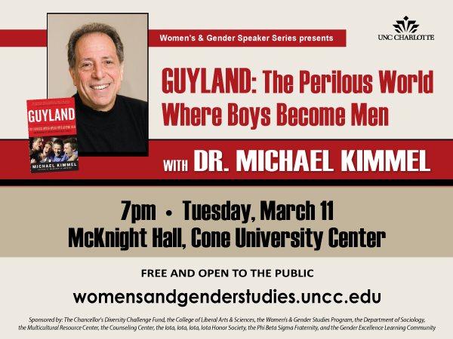

"To a growing list of books about the myths and mysteries of American boys and young males, Kimmel, a sociologist and author of Manhood In America, adds this deft exploration grounded in research. Published by HarperCollins, Guyland is based on more than 400 interviews over a four-year span with young men, ages 16–26. Kimmel’s study shows that the guys who live in “Guyland” are mostly white, middle-class, totally confused and cannot commit to their relationships, work or lives. Although they seem baffled by the riddles of manhood and responsibility, they submit to the “Guy Code,” where locker-room behaviors, sexual conquests, bullying, violence and assuming a cocky jock pose can rule over the sacrifice and conformity of marriage and family. Obsessed with never wanting to grow up, this demographic, which is 22 million strong, craves video games, sports and depersonalized sexual relationships. In the end, Kimmel offers a highly practical guide to male youth."

Michael Kimmel is among the leading researchers and writers on men and masculinity in the world today. The author or editor of more than twenty volumes, his books include Changing Men: New Directions in Research on Men and Masculinity (1987), Men Confront Pornography (1990), The Politics of Manhood (1996), The Gender of Desire (2005) and The History of Men (2005). His documentary history, "Against the Tide: Pro-Feminist Men in the United States, 1776-1990" (Beacon, 1992), chronicled men who supported women’s equality since the founding of the country. This “inspiring, pathbreaking collection of remarkable documents” (Dissent) was also called “meticulously researched” (Booklist) and a “pioneering volume” which “will serve as an inspirational sourcebook for both women and men.” (Publishers’ Weekly).

